How to use vs Player
Step 1: After downloading the compressed package, be sure to extract it locally to your computer.
https://resource.milesight-iot.com/Support/Van/%E8%BD%AF%E4%BB%B6/vs_player_1.4.5.zip
(The latest version is 1.4.7, please download the latest version:
https://resource.milesight-iot.com/Support/Van/%E8%BD%AF%E4%BB%B6/vs_player_1.4.7.zip)

Step 2: Double-click to run the cv_player.exe program.
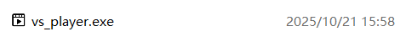
Step 3:
Connect to VS125-P first
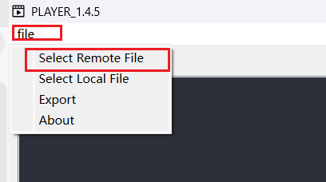
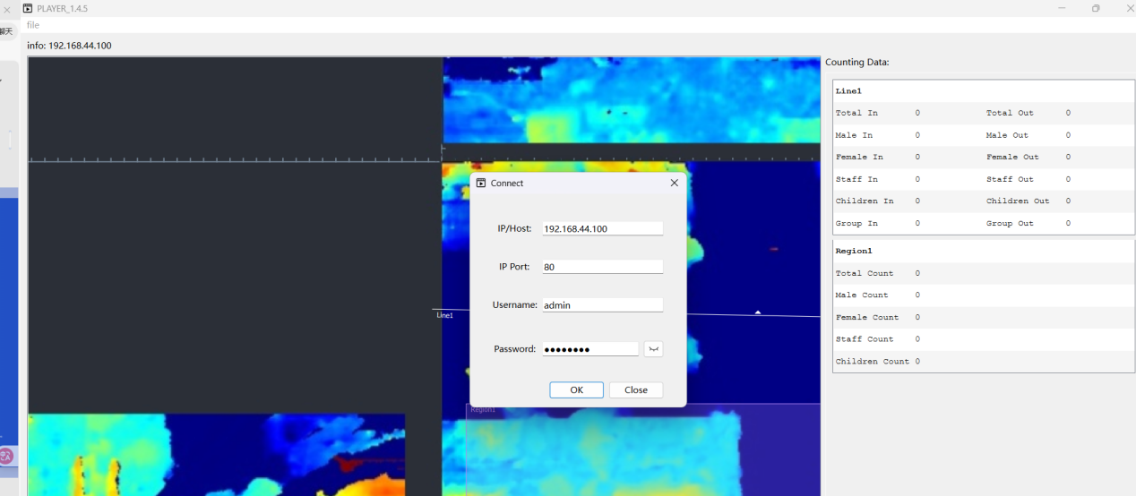

Select the video previously recorded by Validation (Wait for 100% end of loading, because VS125 has two cameras data processing will take a long time, please wait patiently)
Then you can play it on the player
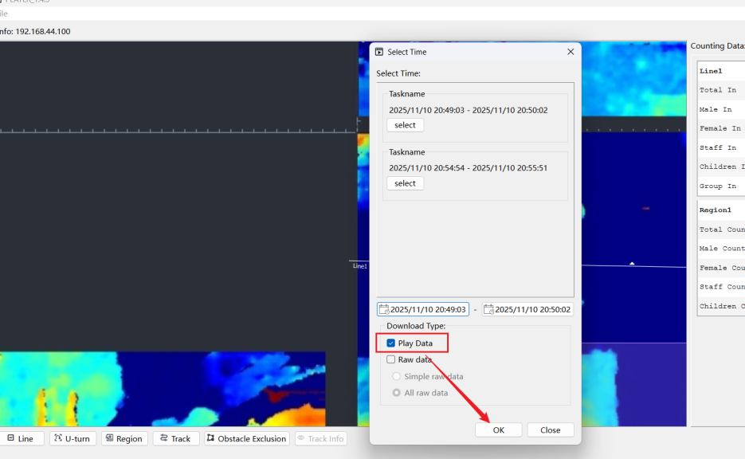

If you want to save the video offline, select Export to export the msv file for future import
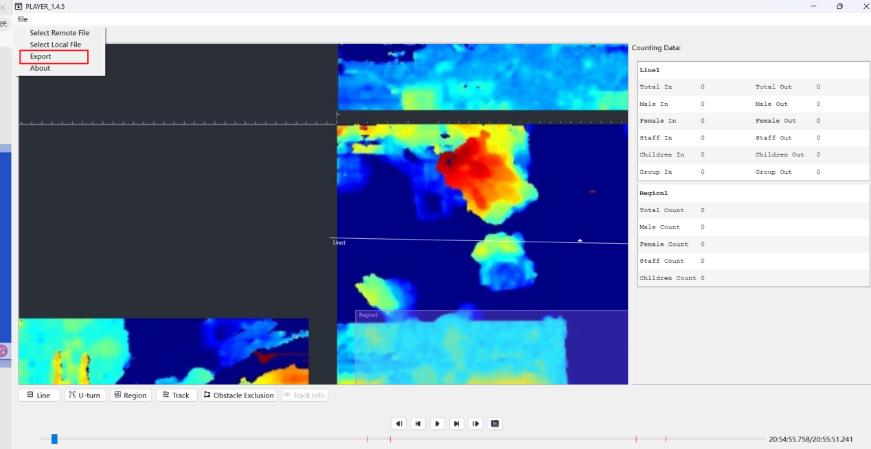
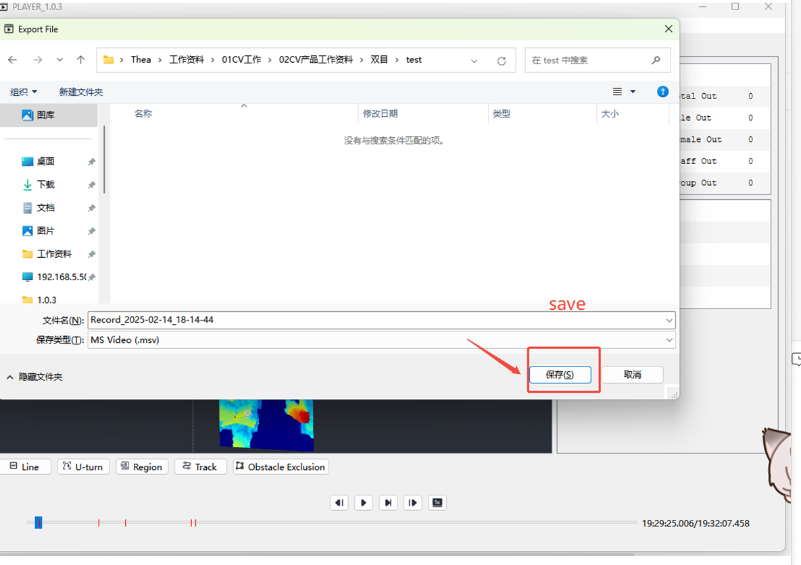

Import a saved local video for playback.
